**Google Cloud Storage: Retention Policies**

**1. Basic Steps**

**Welcome to Cloud Shell! Type "help" to get started.**

**Your Cloud Platform project in this session is set to maximal-park-454214-c8.**

**Use `gcloud config set project [PROJECT_ID]` to change to a different project.**

**ddcbuba@cloudshell:~ (maximal-park-454214-c8)$ gcloud config get-value project**

**Your active configuration is: [cloudshell-29509]**

**maximal-park-454214-c8**

**ddcbuba@cloudshell:~ (maximal-park-454214-c8)$ export BUCKET=$(gcloud config get-value project)**

**Your active configuration is: [cloudshell-29509]**

**ddcbuba@cloudshell:~ (maximal-park-454214-c8)$ gsutil mb "gs://$BUCKET"**

**Creating gs://maximal-park-454214-c8/...**

**ddcbuba@cloudshell:~ (maximal-park-454214-c8)$**

**2. Define a Retention Policy**

ddcbuba@cloudshell:~ (maximal-park-454214-c8)$ gsutil retention get "gs://devi_bucket-1" gs://devi_bucket-1/ has no Retention Policy. ddcbuba@cloudshell:~ (maximal-park-454214-c8)$ gsutil retention get "gs://$BUCKET" Traceback (most recent call last): File "/usr/lib/google-cloud-sdk/platform/gsutil/gsutil", line 21, in gsutil.RunMain() File "/usr/lib/google-cloud-sdk/platform/gsutil/gsutil.py", line 158, in RunMain sys.exit(gslib.**main**.main()) ^^^^^^^^^^^^^^^^^^^^^ File "/usr/lib/google-cloud-sdk/platform/gsutil/gslib/**main**.py", line 436, in main return _RunNamedCommandAndHandleExceptions( ^^^^^^^^^^^^^^^^^^^^^^^^^^^^^^^^^^^^ File "/usr/lib/google-cloud-sdk/platform/gsutil/gslib/**main**.py", line 786, in _RunNamedCommandAndHandleExceptions _HandleUnknownFailure(e) File "/usr/lib/google-cloud-sdk/platform/gsutil/gslib/**main**.py", line 633, in _RunNamedCommandAndHandleExceptions return command_runner.RunNamedCommand(command_name, ^^^^^^^^^^^^^^^^^^^^^^^^^^^^^^^^^^^^^^^^^^^^ File "/usr/lib/google-cloud-sdk/platform/gsutil/gslib/command_runner.py", line 421, in RunNamedCommand return_code = command_inst.RunCommand() ^^^^^^^^^^^^^^^^^^^^^^^^^ File "/usr/lib/google-cloud-sdk/platform/gsutil/gslib/commands/retention.py", line 481, in RunCommand return func() ^^^^^^ File "/usr/lib/google-cloud-sdk/platform/gsutil/gslib/commands/retention.py", line 599, in _GetRetention bucket_url, bucket_metadata = self.GetSingleBucketUrlFromArg( ^^^^^^^^^^^^^^^^^^^^^^^^^^^^^^^ File "/usr/lib/google-cloud-sdk/platform/gsutil/gslib/command.py", line 1275, in GetSingleBucketUrlFromArg blr = list(plurality_checkable_iterator)[0] ^^^^^^^^^^^^^^^^^^^^^^^^^^^^^^^^^^ File "/usr/lib/google-cloud-sdk/platform/gsutil/gslib/plurality_checkable_iterator.py", line 96, in **next** raise six.reraise(item_tuple[1].**class**, item_tuple[1], item_tuple[2]) ^^^^^^^^^^^^^^^^^^^^^^^^^^^^^^^^^^^^^^^^^^^^^^^^^^^^^^^^^^^^^^^^^^ File "/usr/lib/google-cloud-sdk/platform/gsutil/third_party/six/six.py", line 719, in reraise raise value File "/usr/lib/google-cloud-sdk/platform/gsutil/gslib/plurality_checkable_iterator.py", line 70, in _PopulateHead e = next(self.base_iterator) ^^^^^^^^^^^^^^^^^^^^^^^^ File "/usr/lib/google-cloud-sdk/platform/gsutil/gslib/wildcard_iterator.py", line 520, in IterBuckets for blr in self._ExpandBucketWildcards(bucket_fields=bucket_fields): ^^^^^^^^^^^^^^^^^^^^^^^^^^^^^^^^^^^^^^^^^^^^^^^^^^^^^^^^ File "/usr/lib/google-cloud-sdk/platform/gsutil/gslib/wildcard_iterator.py", line 430, in _ExpandBucketWildcards regex = fnmatch.translate(self.wildcard_url.bucket_name) ^^^^^^^^^^^^^^^^^^^^^^^^^^^^^^^^^^^^^^^^^^^^^^^^ File "/usr/lib/google-cloud-sdk/platform/bundledpythonunix/lib/python3.12/fnmatch.py", line 83, in translate i, n = 0, len(pat) ^^^^^^^^ TypeError: object of type 'NoneType' has no len()

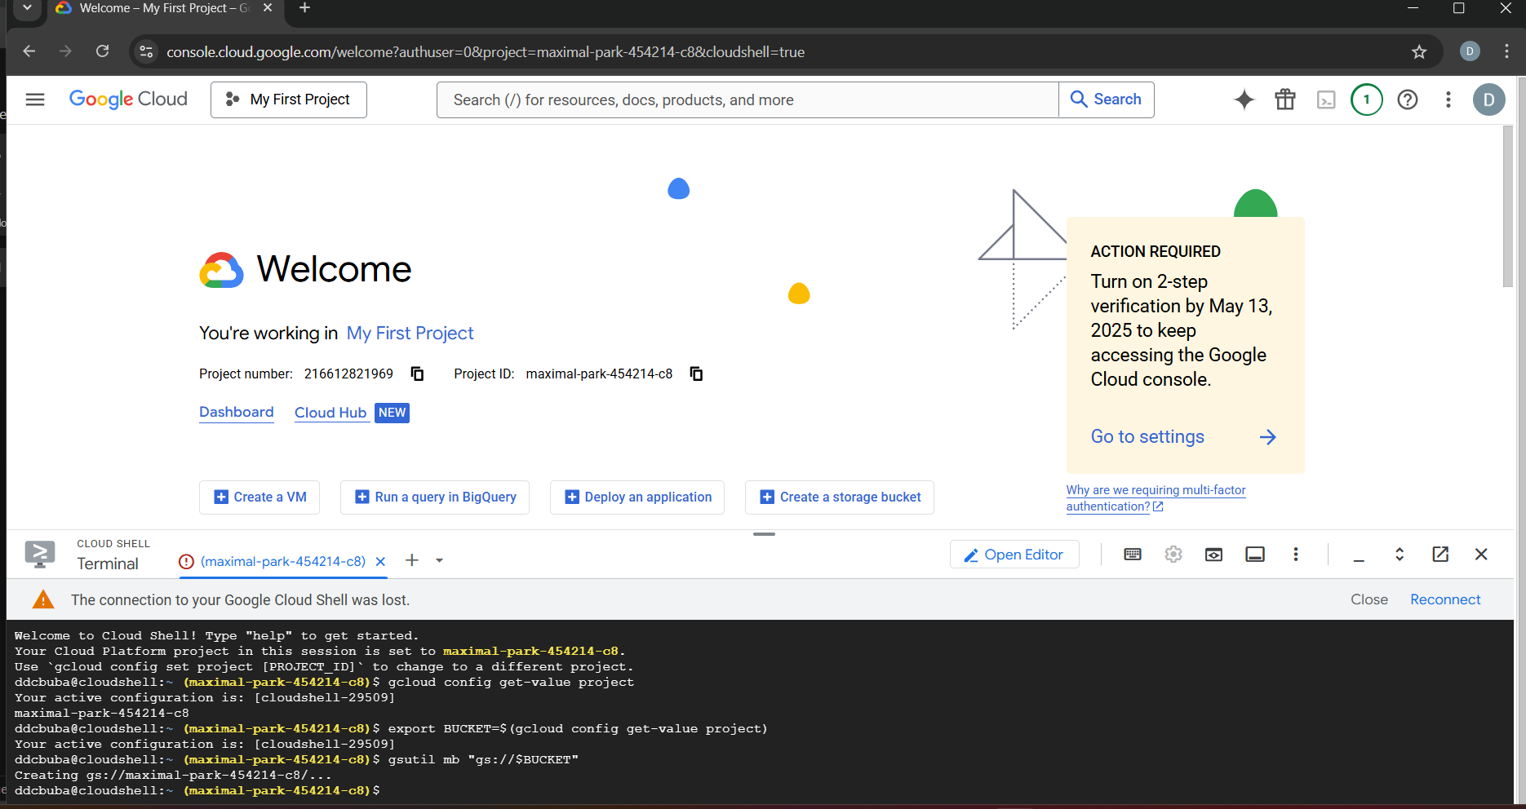

**ddcbuba@cloudshell:~ (maximal-park-454214-c8)$ gsutil retention set 10s "gs://$BUCKET"**

**Setting Retention Policy on gs://maximal-park-454214-c8/...**

**ddcbuba@cloudshell:~ (maximal-park-454214-c8)$ gsutil retention get "gs://$BUCKET"**

**ddcbuba@cloudshell:~ (maximal-park-454214-c8)$ gsutil retention get "gs://$BUCKET"**

**Retention Policy (UNLOCKED):**

**Duration: 10 Second(s)**

**Effective Time: Mon, 21 Apr 2025 20:10:48 GMT**

**Upload a test object:**

**3. Lock the Retention Policy**

**gsutil retention lock "gs://$BUCKET"**

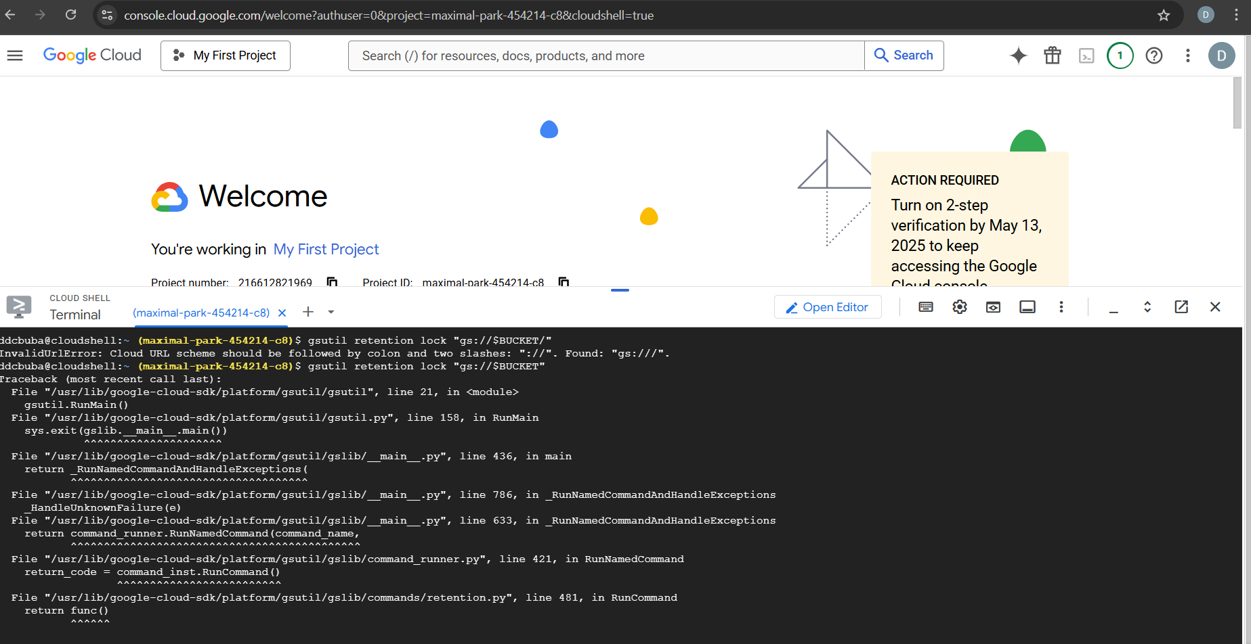

**Check the retention status:**



**4. Temporary Hold**

